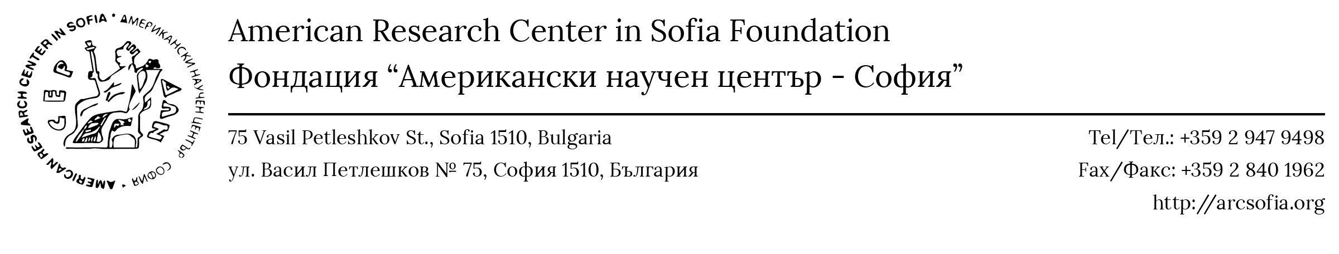
ZVI KEREN RESIDENTIAL FELLOWSHIP IN JEWISH HISTORY

The American Research Center in Bulgaria, Inc. (a tax-exempt U.S. charity and a partner institution of ARCS) and ARCS are proud to announce the Zvi Keren Residential Fellowship in Jewish History, a residential fellowship at ARCS, whose duration may range from one month to a full academic year. The fellowship supports international research by students and scholars in the field of Jewish History in Bulgaria and the region and is established in memory of Dr. Zvi Keren, author of “The Jews of Karnobat,” “Studies of Jewish Life in Bulgaria,” and many other works, and an internationally acclaimed scholar of the history of the Jewish community in Bulgaria throughout the centuries.
ARCS welcomes Zvi Keren Residential Fellows (advanced graduate students, faculty members, or independent researchers) who seek a short- or long-term academic home in Bulgaria. The American Research Centers in Bulgaria and Sofia will provide the fellows with:
- free room and waived administrative fees;
- use of library and office facilities, including copying, printing, and scanning equipment, parking spaces, conference/lecture facilities;
- networking opportunities with local and regional scholars and institutions, and
- overall logistical support.
In addition to conducting their research at ARCS, the Zvi Keren Residential Fellows will contribute to the academic program of ARCS by presenting a small number of lectures or seminars or organizing a regional workshop/conference.
The fellows are encouraged to combine the fellowship with other opportunities in order to cover travel, meals, and incidental expenses.
APPLICATION PROCEDURE: Please complete the application form, renaming it to include your surname, and send it electronically as a PDF. Make sure to include a CV and a Project Description as Microsoft Word documents or as PDFs. All application materials must be in English and PDFs must be emailed to library@arcsofia.org. There is no application deadline but applicants are advised to apply as early as possible.
Please direct any questions about the program to Prof. Kevin Clinton at kmc1@cornell.edu.

APPLICATION FORM FOR THE ZVI KEREN RESIDENTIAL FELLOWSHIP IN JEWISH HISTORY

All application materials must be in English and must be emailed to library@arcsofia.org.

- Applicant’s name:

- Mailing address:
- Email address:

- Phone number:

- Citizenship:

- University/Department/Degree:
- Title of research project:
- Name, position, email address, and phone number of Referee 1 (for graduate students):
- Name, position, email address, and phone number of Referee 2 (for graduate students):
- Please attach a CV of no more than 3 pages.

- Please attach a Project Description of no more than 1,500 words. Include the significance of the project, the kinds of resources you will use and/or fieldwork you will pursue, and your reason for conducting research at ARCS.

