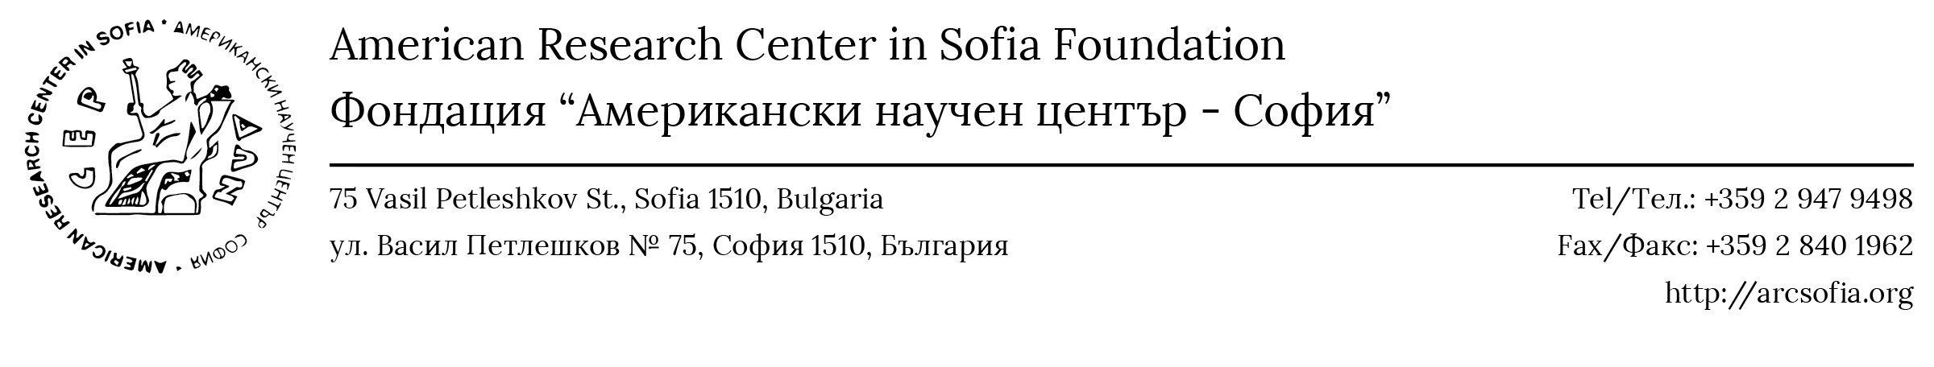
ARCS VISITING SCHOLARS PROGRAM
ARCS welcomes Visiting Scholars (advanced graduate students, faculty members, or independent researchers) who seek a short- or long-term academic home in Bulgaria. The program is primarily intended for scholars currently affiliated with an American institution of higher education or independent scholars in the USA. All scholars receive wide-ranging logistical help and are welcome to use the Library, including multiple online resources; the Center's office spaces; copying, printing, and scanning equipment; parking spaces; and conference/lecture facilities. Administrative fee: $100 per month.
In accordance with the mission of ARCS, the Visiting Scholar Program is open to candidates whose research focuses on any aspect of the Humanities and Social Sciences of Bulgaria and the six other countries we serve from antiquity to the present day. In addition to conducting her/his research based at ARCS, the Visiting Scholar will contribute to the academic program of ARCS by presenting a small number of lectures or seminars or organizing a regional workshop/conference. The ARCS Residential Research provides 24/7 access to the ARCS Library, access to ARCS resources and expertise.
Visiting Scholars have the option of residing at ARCS or finding alternative accommodation (ARCS can help with rental arrangements).
All fees are payable to ARCS's partner institution in the U.S., the American Research Center in Bulgaria, Inc.
APPLICATION PROCEDURE: Please complete the application form, renaming it to include your surname, and send it electronically as a PDF. Make sure to include a CV and a Project Description as Microsoft Word documents or as PDFs. All application materials must be in English and PDFs must be emailed to library@arcsofia.org.

There is no application deadline, but applicants are advised to apply as early as possible.

Please direct any questions about the program to Prof. Kevin Clinton, kmc1@cornell.edu.

APPLICATION FORM FOR ARCS VISITING SCHOLARS
All application materials must be in English and must be emailed to library@arcsofia.org.
- Applicant’s name:
- Mailing address:
- Email address:
- Phone number:
- Citizenship:
- University/Department/Degree:
- Title of research project:
- Name, position, email address, and phone number of Referee 1 (for graduate students):
- Name, position, email address, and phone number of Referee 2 (for graduate students):
- Please attach a CV of no more than 3 pages.
- Please attach a Project Description of no more than 1,500 words. Include the significance of the project, the kinds of resources you will use, and/or fieldwork you will pursue, and your reason for conducting research at ARCS.

